Educational Organization Using Service Now

Team Id: Nm2025TMID19233

Team Members: 4

Team Leader: Thanga Anusuya S

Team Member 1 Sai Dharshini G

Team Member 2 Sandhiya K

Team Member 3 Harini R

Problem Statement:

The Educational Management System is a comprehensive platform designed to streamline administrative tasks within educational institutions. It facilitates efficient management of student and teacher data, simplifies the admission process, and provides tools for monitoring student progress.

Objective:

The main objectives of using ServiceNow in an educational context are to enhance student and faculty experiences by providing seamless, personalized support, to improve administrative efficiency through workflow automation and a unified platform, and to boost IT productivity by eliminating manual processes and centralizing knowledge management.

Ultimately, ServiceNow aims to foster innovation, improve collaboration, and drive digital transformation across the entire institution.

Skills:

Creating A Table, Form Layout, Form Design, Number Maintenance, Process flow, Client Script.

TASK INITATION

Milestone 1: Setting Up ServiceNow Instance

Activity 1: Creating Instance

1. Sign up for a developer account on the ServiceNow Developer site “https://developer.servicenow.com”. Once logged in, navigate to the "Personal Developer Instance" section.
2. Click on "Request Instance" to create a new ServiceNow instance.
3. Fill out the required information and submit the request.
4. You'll receive an email with the instance details once it's ready.
5. Log in to your ServiceNow instance using the provided credentials.
6. Now you will navigate to the ServiceNow.

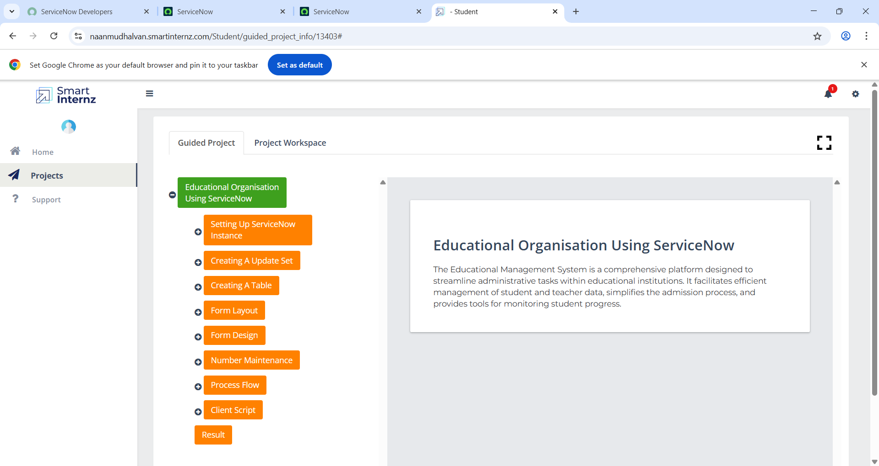

Milestone 2: Creating A Update Set.

1.Click on All >> Local update sets.

2. Click on new.

3.Enter the Details Name: Educational Organisation >> Click on Submit and make Current.

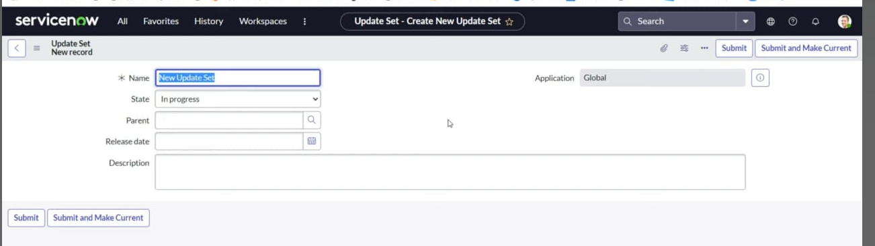

Milestone 3: Creating A Table.

Activity 1: Enter the Details Name: Educational Organisation >> Click on Submit and make Current.

* All >> Tables.
* Click on new
* Enter the Label : Salesforce >> Click on Name it will Automatically generate Api name.

* Create columns as given below, Double Click on Column label and Enter the Column labels and click on the tick mark >> Give Type as given .
* Click on controls >> Enable Extensible.
* 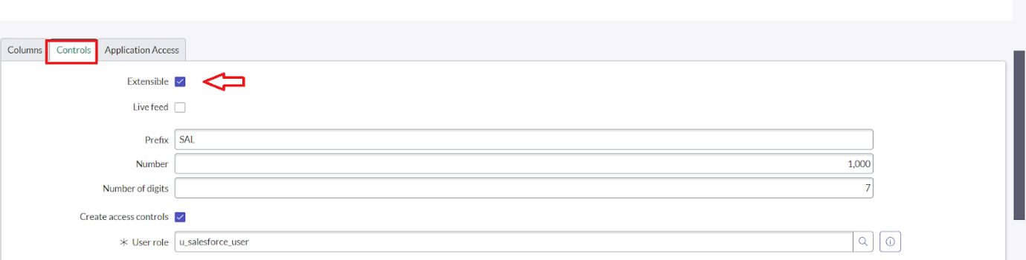
* Click on “Admin Number” column, In Related Links Click on Advanced View >> Default View (Enable Use dynamic default) >> select Get Next Padded Number in Dynamic default value >> Update.

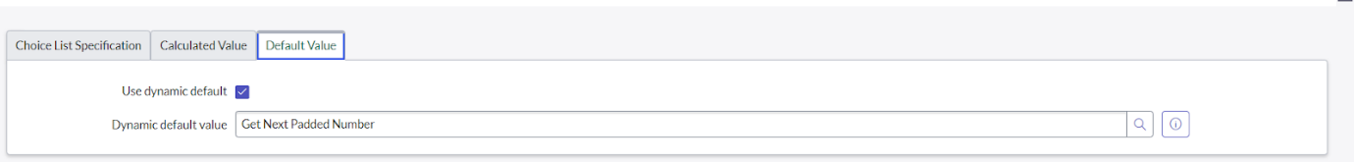

* Click on “Grade” Column >> Click on Choices and give Label, Value and Sequence as given below.

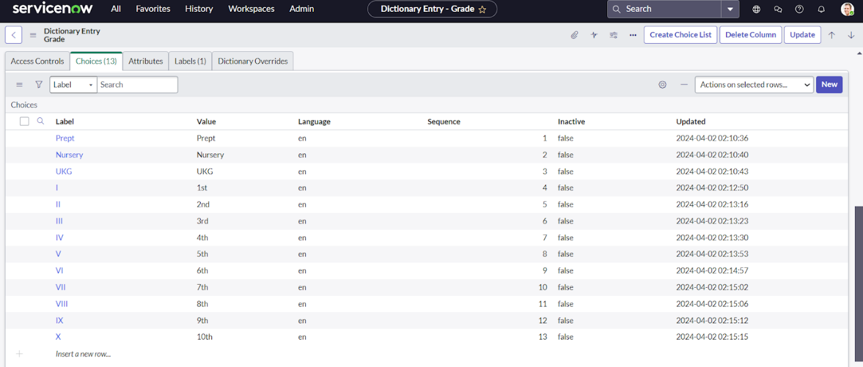

Milestone 3.1: Creating Admission Table.

**Creating Admission Table**

* Create an Admission Table with Columns given.
* Select Extends Table >> Salesforce and also Select Add module to menu >> Salesforce.
* Create Fields as shown
* Create Fields as shown

* Create choice for Admin Status as:

* Create choice for Pin code as:

* Create choice for Purpose of Join as:

* Create choice for School Area as:

Activity 3.2: Creating Student Progress Tables:

**Creating Student Progress Table**

* Create a Student Progress Table with Columns given.
* Select Add module to menu >> Salesforce.
* Create Fields as shown:

Milestone 4: Form Layout

Activity 4: **Configuring Table form for Student Progress Table**

* In the Student Progress Table Page, Click on Layout form .

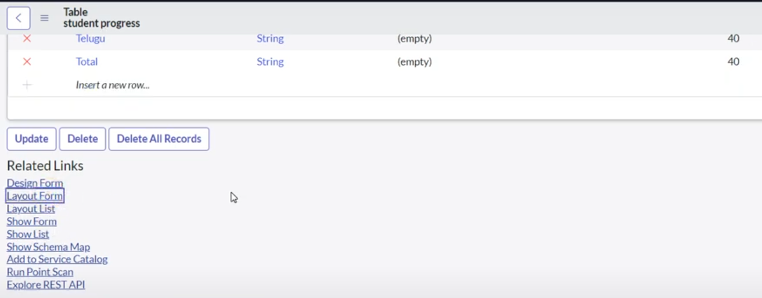

* Click on Admission Number [+].

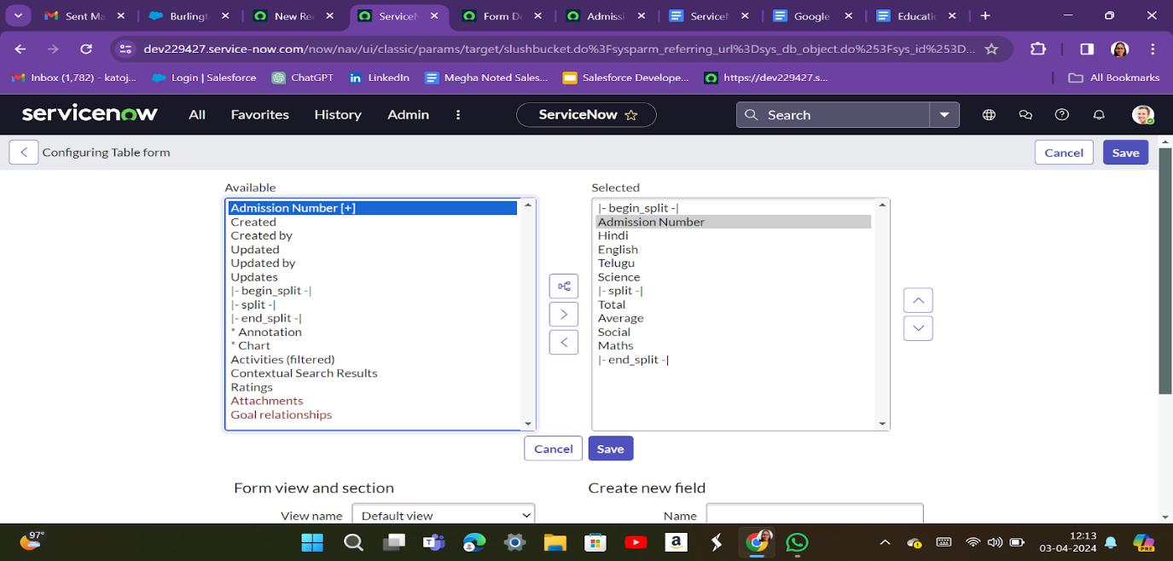

* Select below Admission Number fields in Available side and send it to selected side as below >> save.

Milestone 5: Form Design

* Activity 5: Select below Admission Number fields in Available side and send it to selected side as below >> save.

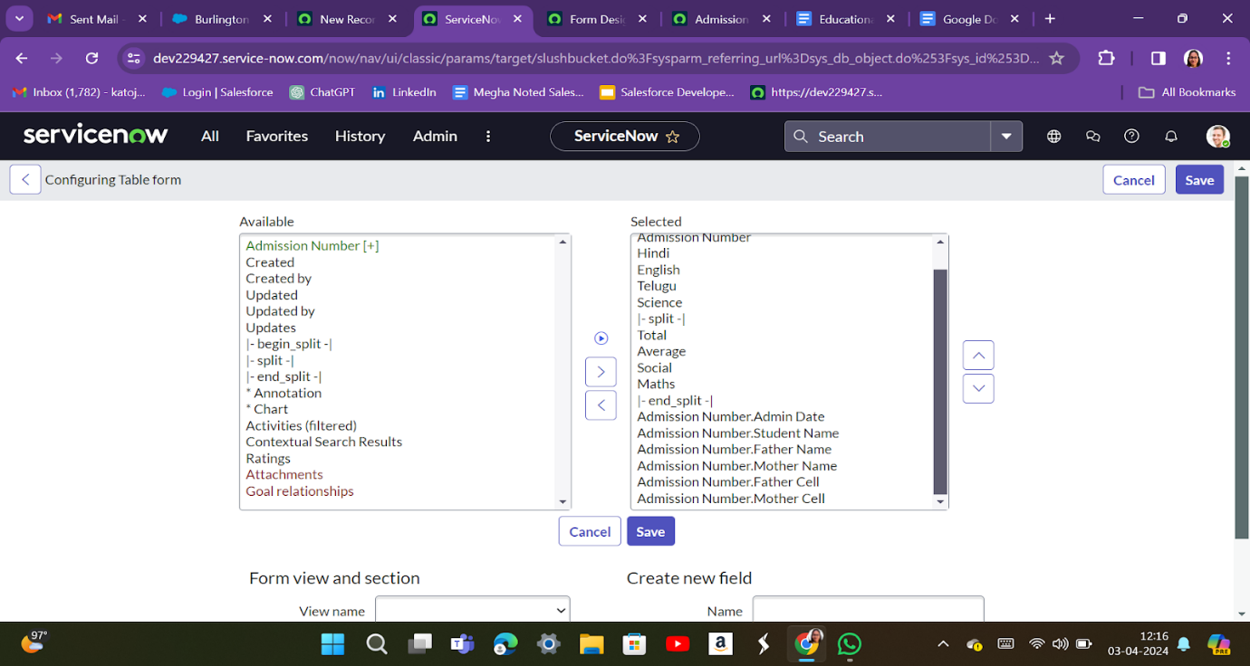

1. In drop down select Salesforce(salesforce).

1. Drag and drop the fields to the left side as below.

      6.Save.

Activity 5.1: **Creating Form Design for Admission Table**

Activity 5.3: **Creating Form Design for Student progress Table**

Milestone 6: **Number Maintenance**

**Creating Number Maintenance for Admin Number**

* All >> Number Maintenance >> New
* Fill the details >> Submit

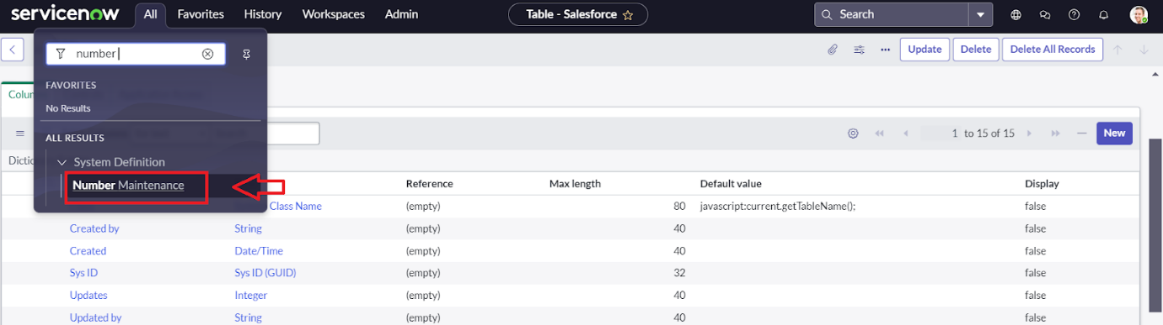

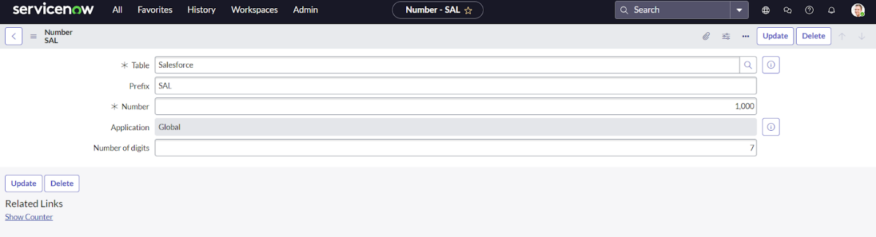

Milestone 6: **Process Flow**

**Creating Process Flow for Admission Table**

* All >> Process Flow>> New.
* Fill the Details as given Below
* Right Click on toggle and click on the save .
* Replace the Name and Label as below and click on Insert on stay.
* Fill the details >> Submit 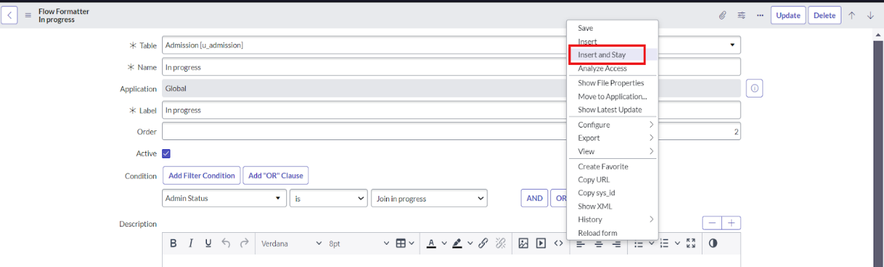Milestone 7: **Client Script**

Activity 7: **Creating “Auto populate” Client Scripts for Admission Table**

* All >> Client Scripts >> New.
* Fill the Details as given.

Activity7.1: **Creating “pin code Update”**

* Fill the Details as given.

Activity 7.2: **Creating “Disable Fields”**

* Fill the Details as given.

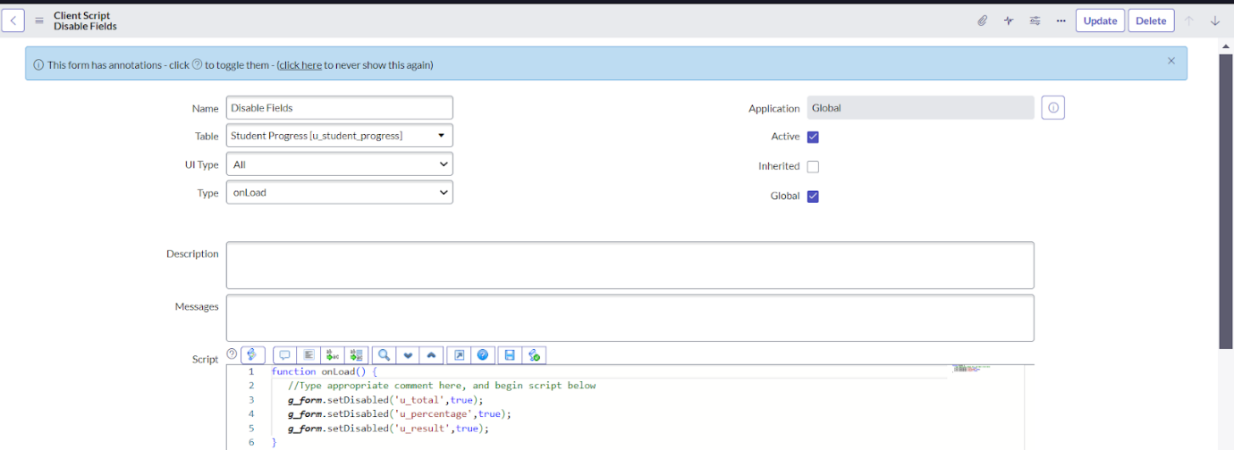

Activity 7.3: **Creating “Result” Client Scripts for Student progress Table**

* Fill the Details as given.

Activity 7.4: **Creating “Percentage” Client Scripts for Student progress Table**

* Fill the Details as given.

Milestone 8: Finishing Step

